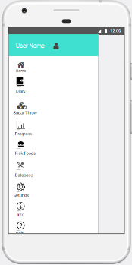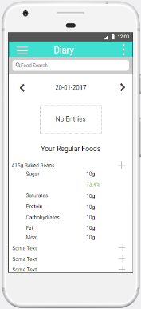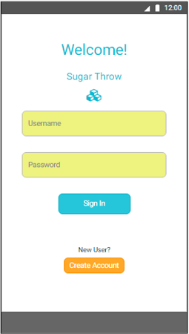

**Writing**

Every time a user enters a food into their diary, they will gain a point and will therefore be allowed to play the Sugar Throw game

Importantly, the foods entered will be examined by the app in terms of their nutritional value. If a user is consistently having unhealthy food, the app will deduct points.

Students are known for their unhealthy lifestyles – research suggests that 59% suffer from malnutrition. Unhealthy behaviours are carried forward into later life, so it is crucial to that their habits are improved for them to stay healthy in the future.

This project aims to encourage students to eat healthy, with an emphasis on them cutting down on their sugar intake.

Subsequently, a gamified smartphone app will be developed and educate students on the risks they are taking

Image

Free-throw game

The app is developed on the Android OS platform which will allow the user to utilise an online database and store the foods they have eaten daily.

Gamification techniques were examined from prior studies and applications, with three distinct practices being used within this app – self-monitoring, feedback, and goal-setting.

**User studies and Evaluation**

To evaluate the app, user studies will be conducted on a sample of students.

**Author: Rich Ellor Supervisor: Peter Flach**

**Sugar Throw**

**Measuring the Effectiveness of a Gamified Smartphone App in Encouraging Healthy Behaviour Amongst Students**